Bash scripting execution step by step
- Bash scripting is powerful way to automate the tasks in linux/unix systems
- It allows you to write sequence of commands in a file and execute them as a script
- A script will consists of set of commands which will help us to automate the system
- Launch an instance and connect to server by the command -> ssh -I webserver.pem ec2-user@publicip
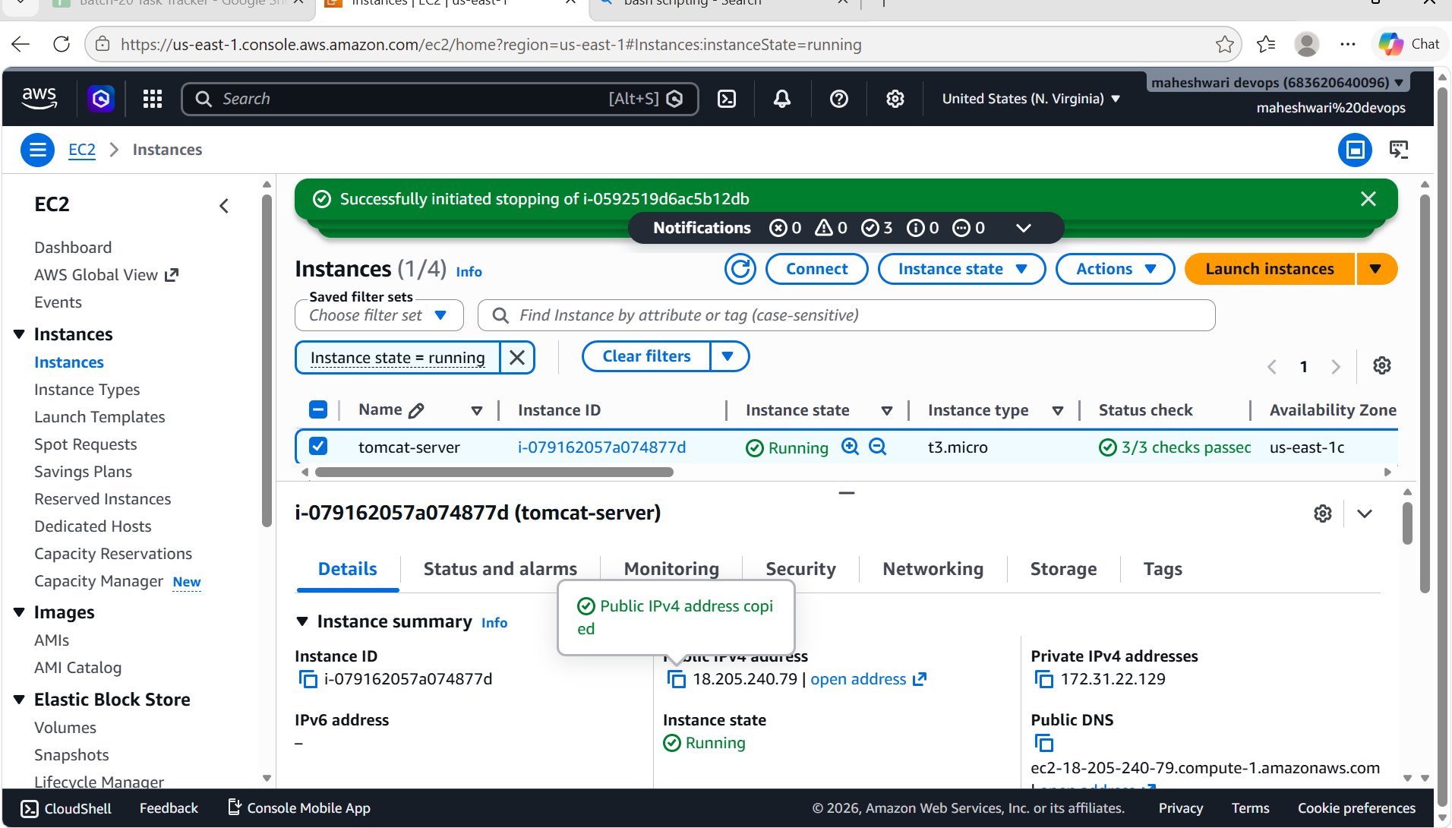
- Example of bash scripting to run commands
- 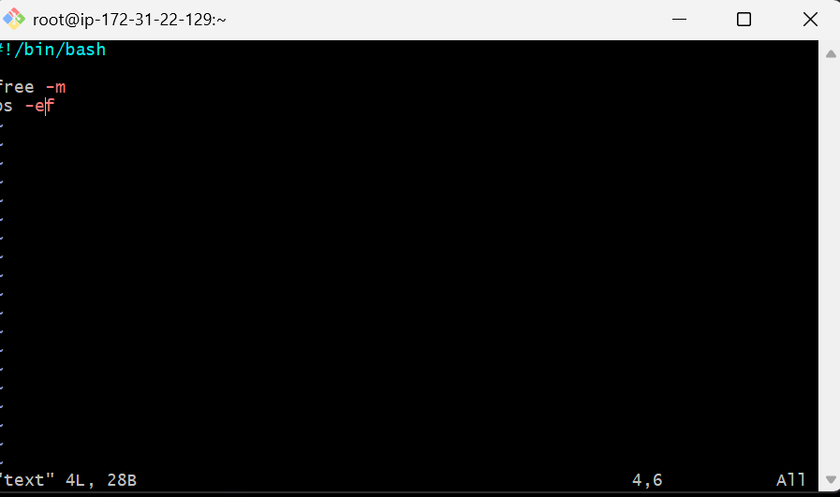
- Create a file with extension .sh -> vi test.sh
- and change the permissions to 755 -> chmod 755 test.sh
- Run the command -> ./test.sh or bash test.sh
- 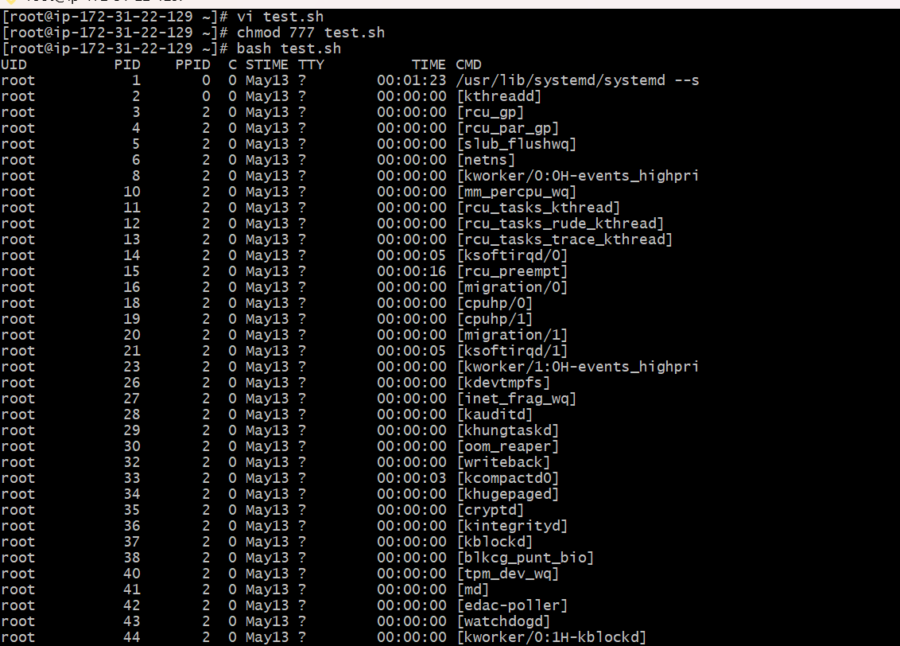
To find current shell and available shells in the system
- Outcome -> to know current sheel, available shells and user assigned shell
- echo $0 command is used to which shell is using at present
- cat /etc/shells is used to know the available shells
- cat /etc/passwd is used to know which shell user is assigned with.
TYPES OF SHELLS
1.Gnome
2.KDE
3.sh
4.bash
5.csh & tcsh
6.ksh
- to switch the shell we can use the shell name ex:sh and to get exit from that use exit command.
SCRIPTING STANDARDS
1.script naming convention:
- always create a directory to store scripts
- script name should identify the functions
- script should end with shell
2.script format:
- define shell
- comments
- define variables
- commands
- statements
3.input/output script:
read -> to take input from user
Echo -> to print the output

TASK-1: echo $helloworld
Outcome: to get the helloworld to be printed
Objective: to execute a basic bash script
Prerequisites:
- create a directory called scripts to store all the scripts
- give the extension to a script name with shell ex: .sh, .bash
Step by step implementation:
- first create a file -> test.sh
- edit the file -> vi test.sh
- add script to the file
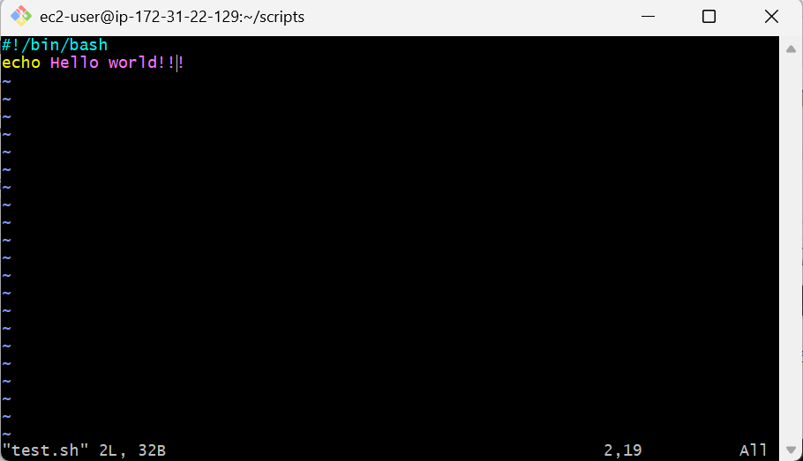

- then change the permissions to the file -> chmod 755 test.sh
- run the command to get the outcome -> ./test.sh or bash test.sh

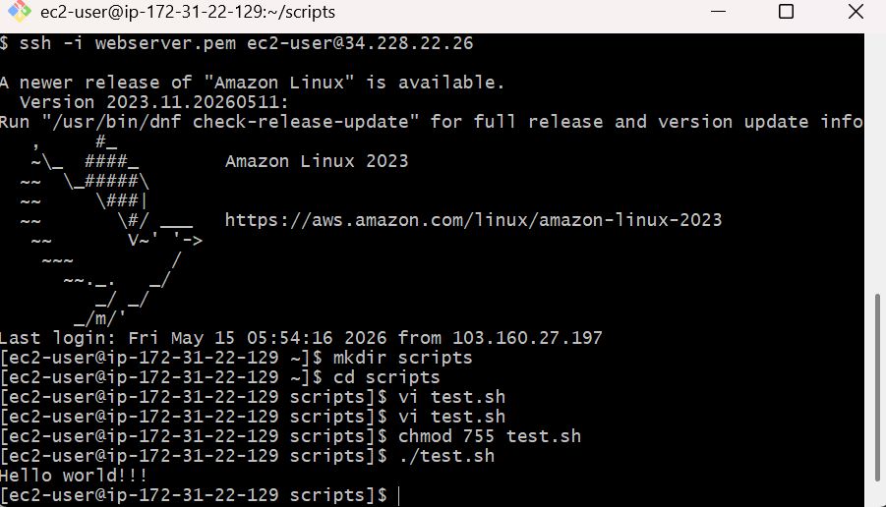

Task -2 : Defining tasks
Outcome: execution of commands from top to bottom
Objective: to automate the commands
Step by step implementation:
- adding a set of commands to a script and it will execute from top bottom
- create a file -> commands.sh
- add the content to the fil

- change the permissions -> chmod 755 commands.sh

- then run the commands to get the output -> ./commands.sh

task -3: Basic script
Outcome: runs the commands that are added in the script and creates files of a b c
Objective: execute the basic script
Step by step implementation:
- creates a file -> vi commands.sh
- add the content
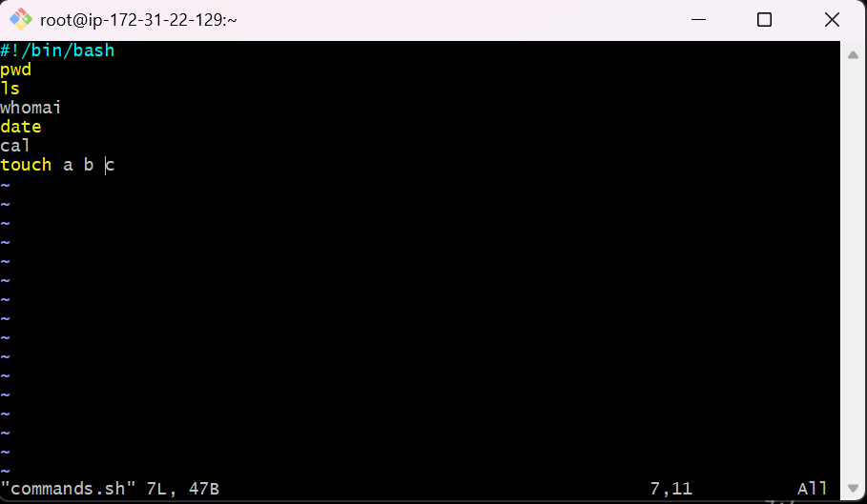
- change the permissions by chmod command
- run the command ./commands.sh to get the output
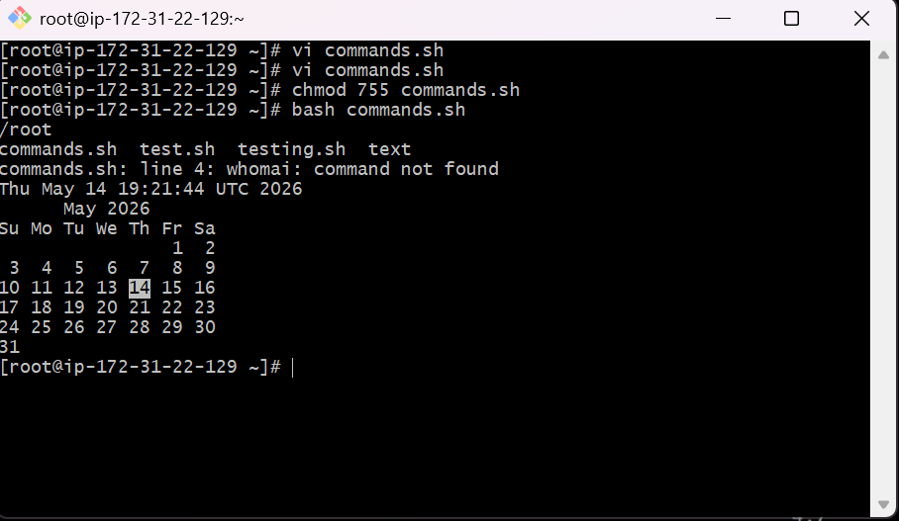

Task -4: top command in the script
Outcome: top command gets struck because it continuously monitor
Objective: To resolve the issue of top command that stopping the execution of other commands in the script
Step by step implementation:
- create file in scripts directory
- edit the script by using head command
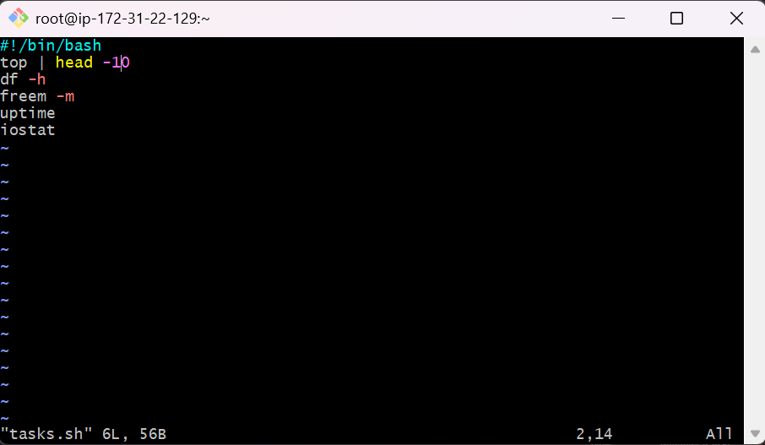
- run the command -> ./tasks.sh
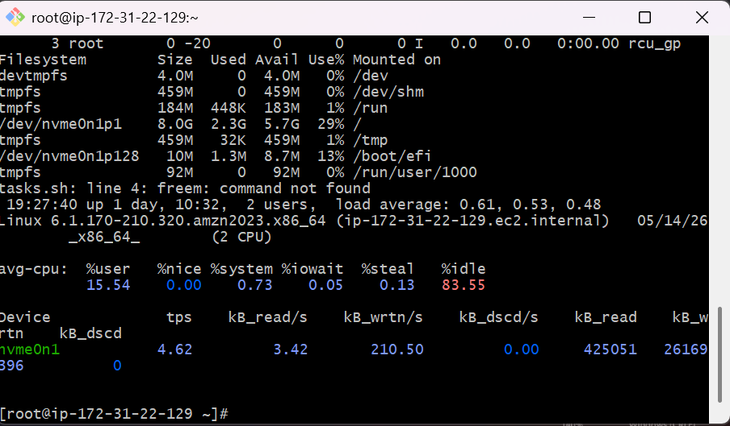

Task – 4: input and output script
Outcome: will get a output with a cursor so that we have to give the input
Objective: how to give a input to the output
Step by step implementation:
- create a file ->read.sh
- edit the script
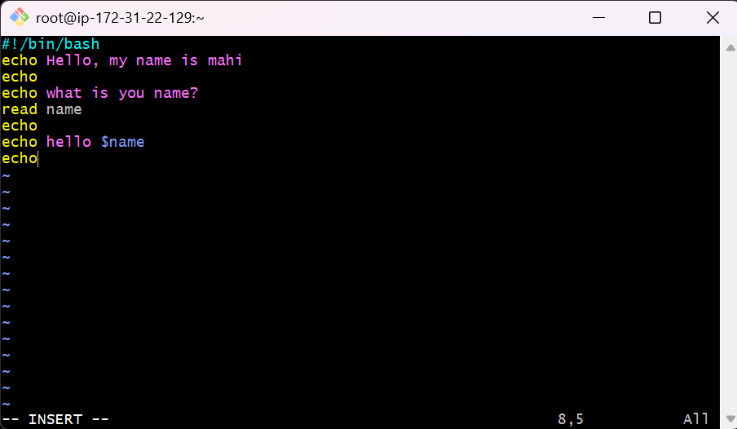

- run the command -> ./read.sh
- we will get a cursor in the output and give the input that have been asked and wait for the output

